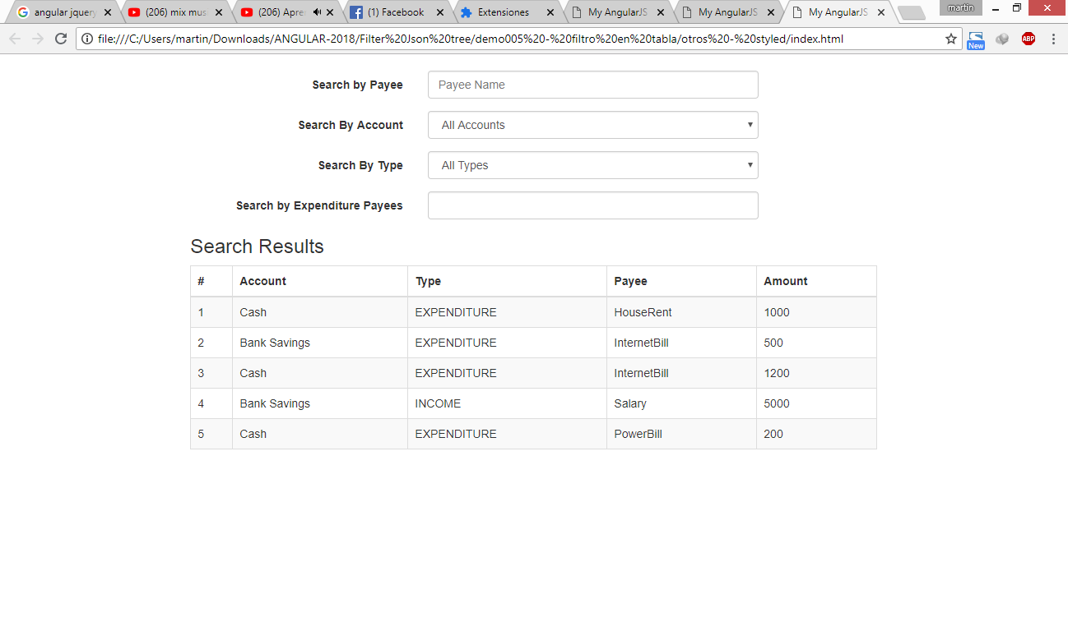

<https://www.javacodegeeks.com/2014/09/angularjs-different-ways-of-using-array-filters.html>

<https://dzone.com/articles/angularjs-different-ways-using>

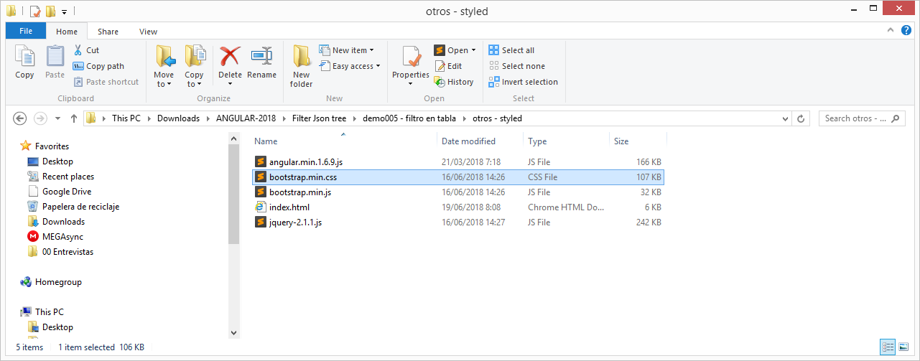

1. angular.min.1.6.9.js (AngularJS v1.6.9)
2. bootstrap.min.css (Bootstrap v3.2.0 (<http://getbootstrap.com>)
3. bootstrap.min.js (Bootstrap v3.2.0 (<http://getbootstrap.com>)
4. jquery-2.1.1.js (jQuery JavaScript Library v2.1.1, de preferencia usar versions posteriors a 1.5.6, recuerda que tal vez sea necesario inicializar las variables…)

Index.html

|  |
| --- |
| <!DOCTYPE html>  <html ng-app="myApp">  <head>  <meta charset="utf-8">  <meta http-equiv="X-UA-Compatible" content="IE=edge">  <title>My AngularJS App</title>  <meta name="description" content="">  <meta name="viewport" content="width=device-width, initial-scale=1">  <link href="bootstrap.min.css" rel="stylesheet" type="text/css" />  <!-- <script src="angular.min.js"></script> <<< NOT WORKING-->  <script src="angular.min.1.6.9.js"></script>  <script src="jquery-2.1.1.js"></script>  <script src="bootstrap.min.js"></script>  <script>  var myApp = angular.module('myApp', []);  myApp.controller('SampleController', function ($scope) {  $scope.accounts = [  { id: 1, name: 'Cash' },  { id: 2, name: 'Bank Savings' }  ];  $scope.payees = [  { id: '1', name: 'HouseRent', txnType: 'EXPENDITURE' },  { id: '2', name: 'InternetBill', txnType: 'EXPENDITURE' },  { id: '3', name: 'PowerBill', txnType: 'EXPENDITURE' },  { id: '4', name: 'Salary', txnType: 'INCOME' }  ];  $scope.transactions = [  { id: '1', txnType: 'EXPENDITURE', amount: 1000, account: $scope.accounts[0], payee: $scope.payees[0] },  { id: '2', txnType: 'EXPENDITURE', amount: 500, account: $scope.accounts[1], payee: $scope.payees[1] },  { id: '3', txnType: 'EXPENDITURE', amount: 1200, account: $scope.accounts[0], payee: $scope.payees[1] },  { id: '4', txnType: 'INCOME', amount: 5000, account: $scope.accounts[1], payee: $scope.payees[3] },  { id: '5', txnType: 'EXPENDITURE', amount: 200, account: $scope.accounts[0], payee: $scope.payees[2] }  ];  });  myApp.filter('expenditurePayeeFilter', [function ($filter) {  return function (inputArray, searchCriteria, txnType) {  if (!angular.isDefined(searchCriteria) || searchCriteria == '') {  return inputArray;  }  var data = [];  angular.forEach(inputArray, function (item) {  if (item.txnType == txnType) {  if (item.payee.name.toLowerCase().indexOf(searchCriteria.toLowerCase()) != -1) {  data.push(item);  }  }  });  return data;  };  }]);  </script>  </head>  <body ng-controller="SampleController">  <br />  <div class="col-md-8 col-md-offset-2">  <form class="form-horizontal" role="form">  <div class="form-group">  <label for="input1" class="col-sm-4 control-label">Search by Payee</label>  <div class="col-sm-6">  <input type="text" class="form-control" id="input1" placeholder="Payee Name" ng-model="filterTxn.payee.name">  </div>  </div>  <div class="form-group">  <label for="input2" class="col-sm-4 control-label">Search By Account</label>  <div class="col-sm-6">  <select id="input2" class="form-control" ng-model="filterTxn.account">  <option value="">All Accounts</option>  <option ng-repeat="item in accounts" value="{{item.id}}">**{{**item.name**}}**</option>  </select>  </div>  </div>  <div class="form-group">  <label for="input3" class="col-sm-4 control-label">Search By Type</label>  <div class="col-sm-6">  <select id="input3" class="form-control" ng-model="filterTxn.txnType">  <option value="">All Types</option>  <option value="EXPENDITURE">EXPENDITURE</option>  <option value="INCOME">INCOME</option>  </select>  </div>  </div>  <div class="form-group">  <label for="input4" class="col-sm-4 control-label">Search by Expenditure Payees</label>  <div class="col-sm-6">  <input id="input4" type="text" class="form-control" ng-model="searchCriteria">  </div>  </div>  </form>  <h3>Search Results</h3>  <table class="table table-striped table-bordered">  <thead>  <tr>  <th>#</th>  <th>Account</th>  <th>Type</th>  <th>Payee</th>  <th>Amount</th>  </tr>  </thead>  <tbody>  <tr ng-repeat="txn in transactions| filter: filterTxn | expenditurePayeeFilter:searchCriteria:'EXPENDITURE'">  <td>**{{**$index + 1**}}**</td>  <td>**{{**txn.account.name**}}**</td>  <td>**{{**txn.txnType**}}**</td>  <td>**{{**txn.payee.name**}}**</td>  <td>**{{**txn.amount**}}**</td>  </tr>  </tbody>  </table>  </div>  </body>  </html> |